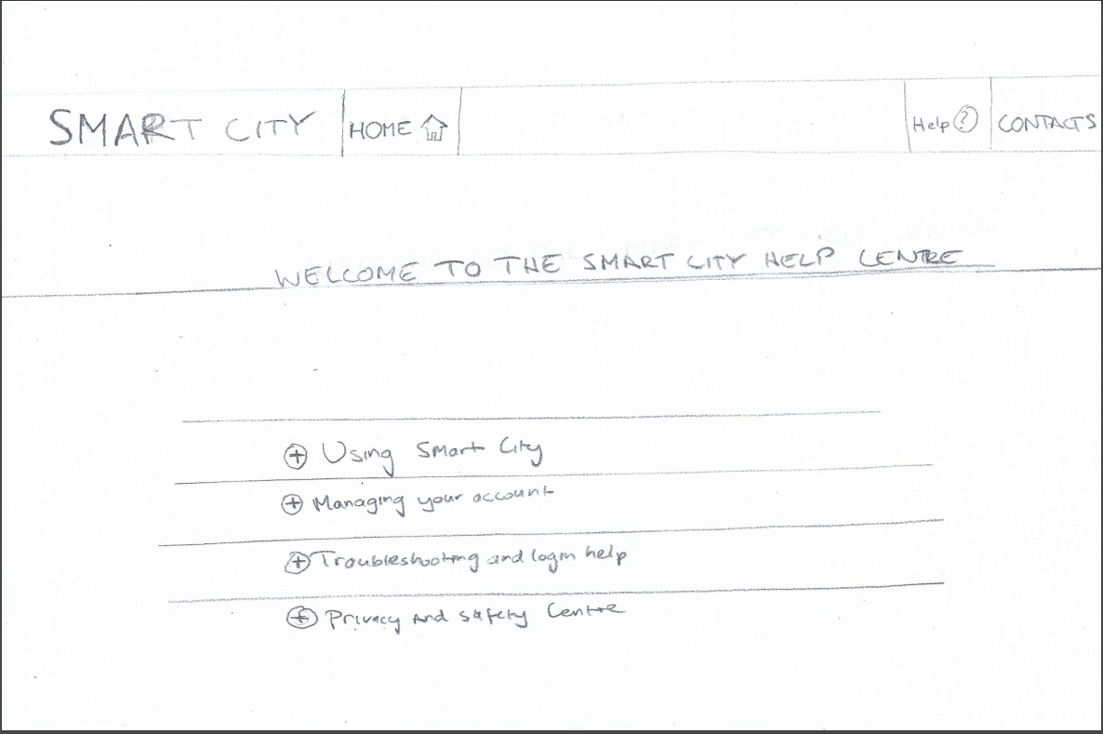Version 1 of Help page mock-up – Paper design

Version 2 of Help page mock-up – High fidelity design 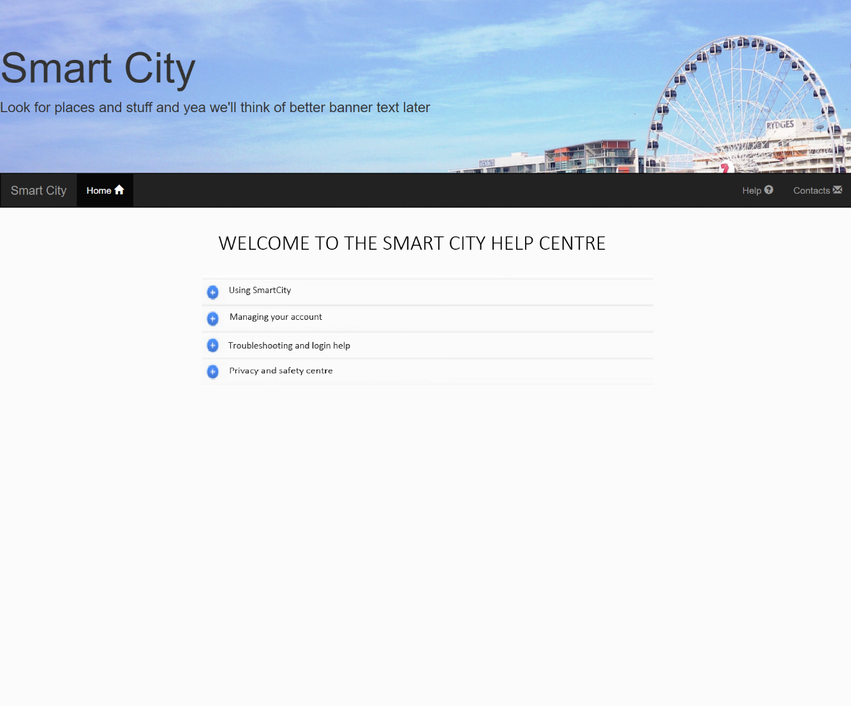

**Version 3 of Help page mock-up – High fidelity design – Final Version**

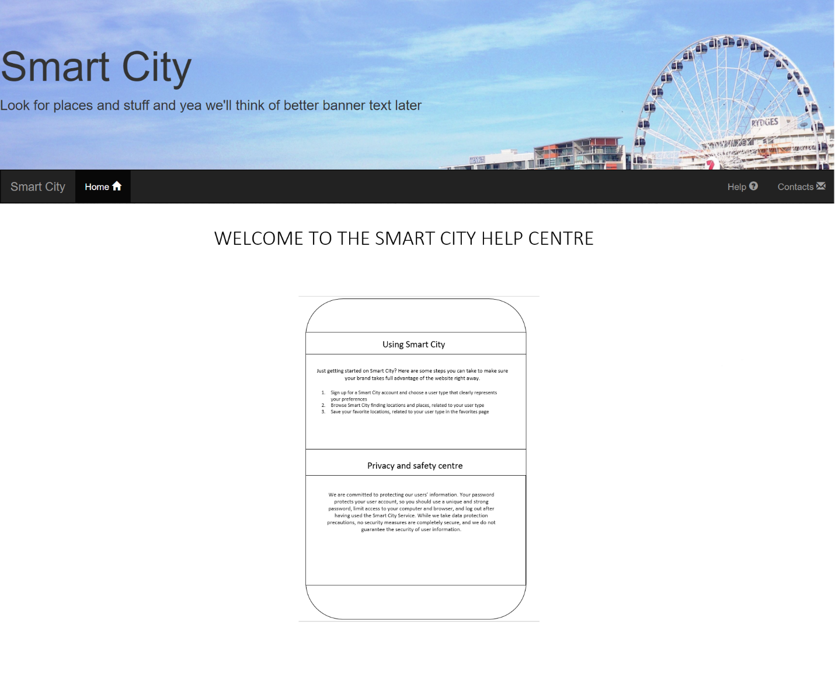

Troubleshooting and login help